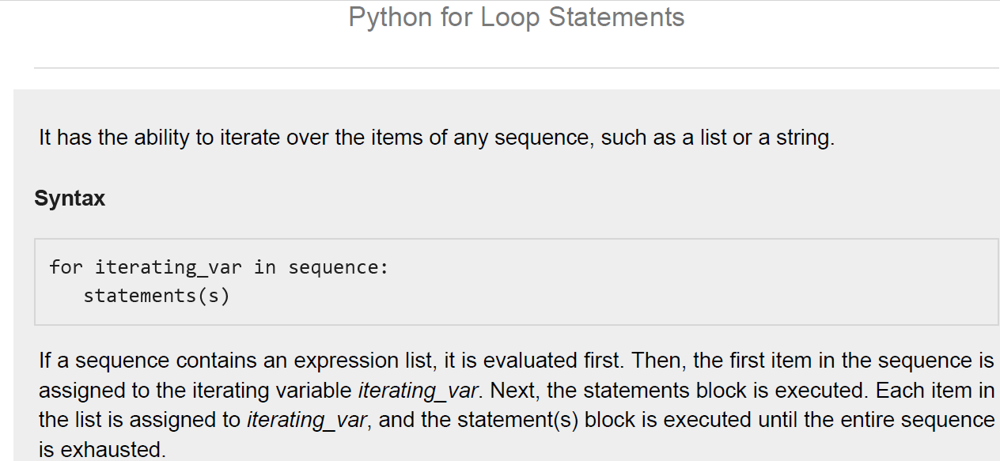

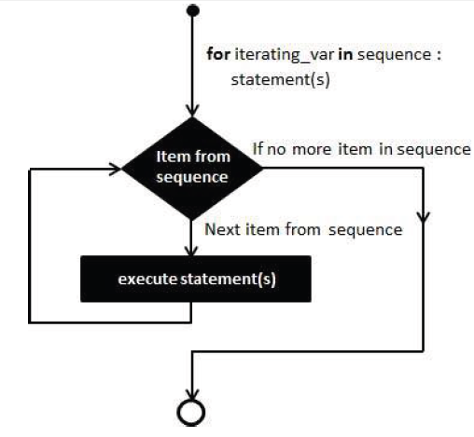

*# Example*

**for** letter **in 'Python':**

**print** ':''Current Letter :', letter

fruits == [['banana', 'apple', 'mango']]

**for** fruit **in fruits**:

**print** ':''Current fruit :',, fruit

**print** "Good bye!"

**Output:**

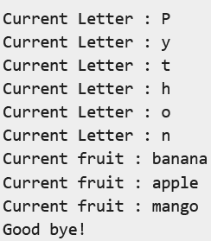

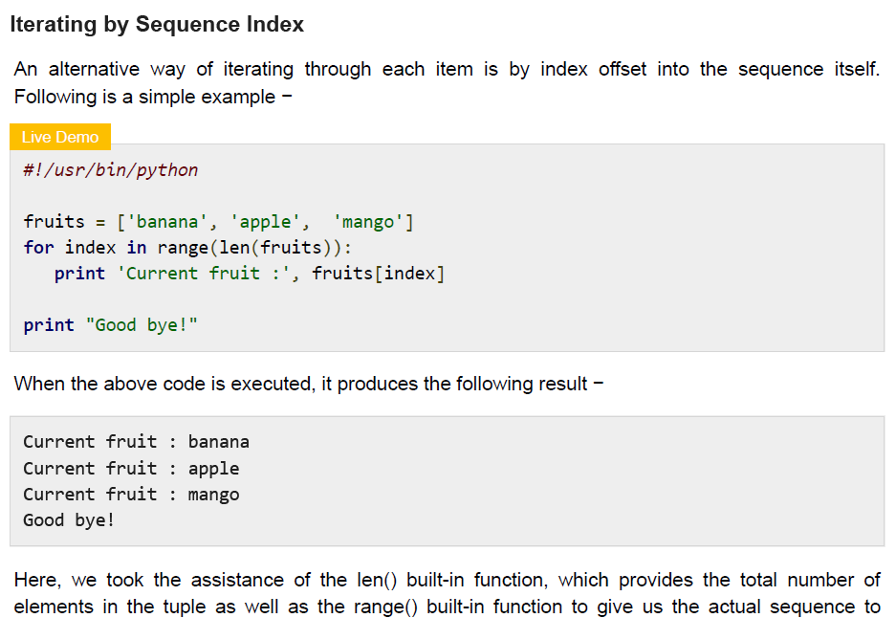



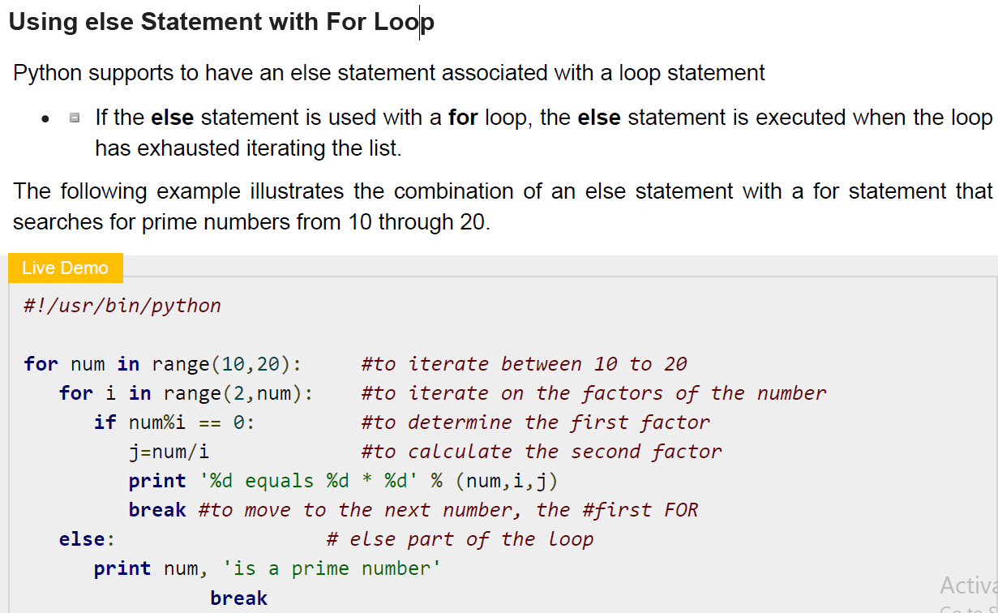

**Output:**

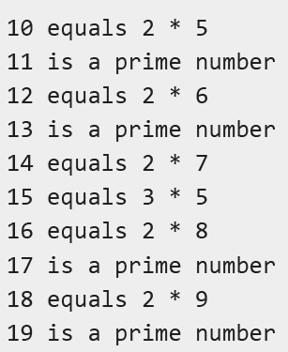

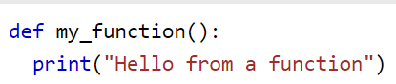

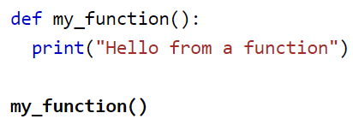

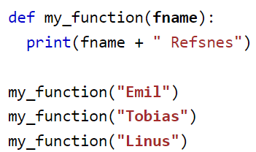

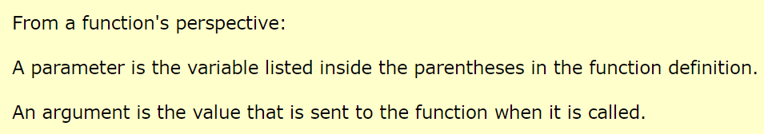

def my_function(fname, lname):

print(fname + " " + lname)

my_function("Emil", "Refsnes")

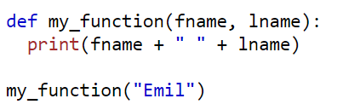

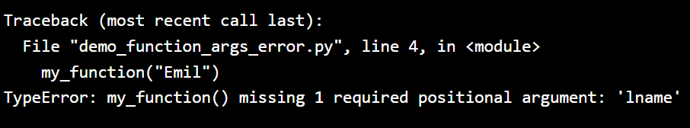

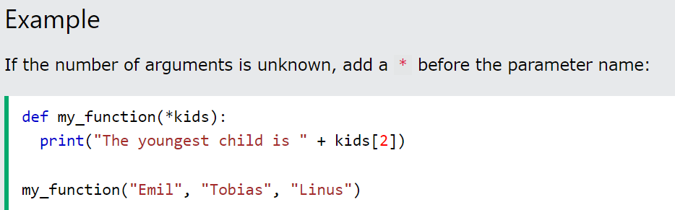



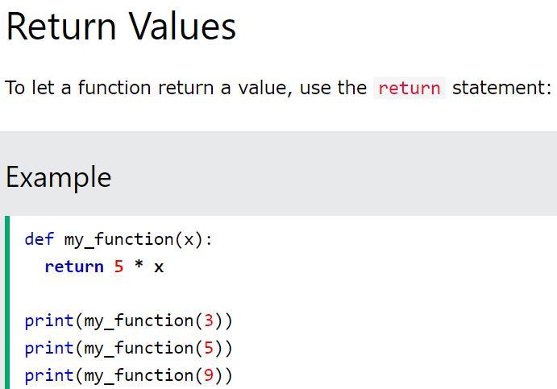



**The pass Statement**

function definitions cannot be empty, but if you for some reason have a function definition with no content, put in the pass statement to avoid getting an error.

def myfunction():  
  pass

